**FEASIBILITY STUDY**

**Introduction**  
This feasibility study evaluates the technical, operational, and economic viability of the Emergency Response Coordination System (ERCS), a project designed to enhance emergency response coordination. This study provides a thorough analysis of the technological requirements, operational impacts, and economic feasibility, ensuring that the project is practical, sustainable, and valuable for stakeholders. Each component addresses potential risks, benefits, and implementation strategies to support the successful execution of ERCS.

**Technical Feasibility**

1. **Evaluation of the Technology Requirements for the Software Solution**

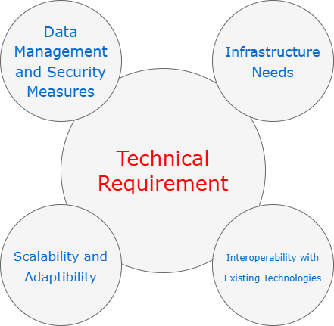

* + **Infrastructure Needs**:
    - ERCS requires a highly scalable and reliable infrastructure to support real-time data processing and communication. Cloud platforms like **AWS** or **Microsoft Azure** are suitable due to their robust scalability, flexibility, and data security features, ensuring that the system can handle variable loads during emergencies.
    - **Frontend Technologies**: The user interface will be developed using frameworks like **React** or **Angular**, which offer responsive design and seamless interaction. These frameworks support multi-device compatibility, ensuring accessibility for users on desktops, tablets, and mobile devices.
    - **Database Management**: A hybrid database solution will be used, combining **PostgreSQL** for structured data and **MongoDB** for unstructured data. This setup allows efficient data retrieval and flexibility, supporting the system’s diverse data needs, including incident reports, responder availability, and GIS data.
  + **Network Infrastructure**:
    - A reliable network infrastructure is critical for real-time data transmission. **Content Delivery Networks (CDNs)** and **load balancers** will optimize data flow and reduce latency, ensuring consistent communication, even under high loads.
  + **API and Third-Party Integrations**:
    - ERCS will integrate with existing systems through RESTful APIs, allowing interoperability with emergency services, hospitals, and government databases. **Standardized data formats** (e.g., JSON, XML) will facilitate smooth data exchange across platforms.
  + **Scalability, Security, and Performance**:
    - **Scalability**: A **microservices architecture** with containerization (using Docker or Kubernetes) enables independent scaling of system components, allowing ERCS to manage increased loads flexibly.
    - **Security**: Data security is paramount due to the sensitive nature of emergency data. ERCS will employ **end-to-end encryption**, **multi-factor authentication (MFA)**, **role-based access control (RBAC)**, and **AI-driven anomaly detection** to safeguard against unauthorized access.
    - **Performance**: Real-time data processing and low latency are prioritized to ensure the responsiveness of ERCS during emergencies.

1. **Assessment of the Feasibility of Implementing the Required Technology** 
   * **Availability of Technology**:
     + The technology stack (cloud infrastructure, frontend frameworks, databases) is mature and widely available. Open-source components and established platforms (e.g., AWS, Docker) reduce the risk associated with technology availability, while offering flexibility for customization.
   * **Technical Expertise**:
     + Skilled personnel, including developers, data scientists, and security experts, are crucial for ERCS. A hiring strategy will prioritize individuals experienced in cloud infrastructure, API integration, and cybersecurity to ensure successful implementation.
   * **Technical Risks and Mitigation Strategies**:
     + **Integration Challenges**: Integrating ERCS with existing emergency systems may present compatibility issues. This risk is mitigated by using standardized data formats and conducting thorough compatibility testing.
     + **Security Risks**: Sensitive data handling increases vulnerability to breaches. ERCS mitigates this through robust security protocols, including encryption, RBAC, and regular security audits.
     + **Scalability Challenges**: Handling high demand during large-scale emergencies may strain resources. Using a microservices architecture with containerized components will support scalability without impacting performance.
   * **Future Technological Advancements**:
     + ERCS is designed to adapt to advancements in AI, IoT, and machine learning, which could further enhance features like predictive analytics and automated resource allocation.

**Risk vs. Reward Analysis**

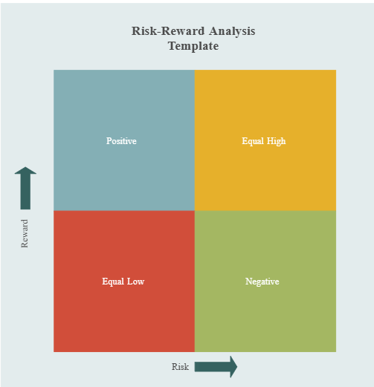

**Quadrant 1: Positive (High Reward, Low Risk)**

These decisions offer substantial rewards with minimal risks, making them safe, highly favorable choices for the ERCS project.

1. **Cloud Infrastructure for Scalability**:
   * **Reward**: High scalability, flexibility, and reliability during peak emergency loads.
   * **Risk**: Low, as established providers (AWS, Azure) offer secure and reliable services.
   * **Rationale**: Cloud infrastructure is essential for scalability, providing high value with low risk.
2. **Frontend Frameworks (React or Angular)**:
   * **Reward**: Responsive and user-friendly interfaces accessible across devices, enhancing user experience.
   * **Risk**: Low, as these frameworks are mature and widely supported.
   * **Rationale**: Offers high usability with minimal risk, supporting a broad user base.
3. **Standardized Data Formats (JSON, XML)**:
   * **Reward**: Ensures compatibility and smooth data transfer with external systems.
   * **Risk**: Low, as these formats are universally supported.
   * **Rationale**: A safe and reliable choice that facilitates data exchange with minimal technical risk.

**Quadrant 2: Equal High (High Reward, High Risk)**

These decisions have significant rewards but also involve higher risks, which require careful management.

1. **Microservices Architecture with Containerization (Docker/Kubernetes)**:
   * **Reward**: Independent scalability and fault tolerance for different system components.
   * **Risk**: High, due to complex setup and specialized skills required for container orchestration.
   * **Rationale**: The modularity and resilience benefits justify the complexity, and additional training mitigates risks.
2. **Advanced Security Measures (Encryption, Multi-Factor Authentication, Anomaly Detection)**:
   * **Reward**: Strong data security and regulatory compliance, essential for protecting sensitive information.
   * **Risk**: High, with increased setup complexity and costs.
   * **Rationale**: Security is critical; these protocols are necessary despite added costs and complexity.
3. **Anomaly Detection with AI for Security Monitoring**:
   * **Reward**: Enhances system security by identifying unusual activities in real time.
   * **Risk**: High, as AI-driven anomaly detection requires continuous training and monitoring.
   * **Rationale**: Real-time monitoring provides significant benefits for data protection, making the complexity worthwhile.

**Quadrant 3: Equal Low (Low Reward, Low Risk)**

These decisions have minimal impact on both reward and risk. While safe, they don’t contribute significantly to the project’s success.

1. **Use of Standardized Data Formats (JSON, XML)**:
   * **Reward**: Facilitates interoperability with external systems.
   * **Risk**: Low, as it’s a widely used and low-complexity approach.
   * **Rationale**: Although it has limited transformative impact, it ensures basic compatibility without risk.

**Quadrant 4: Negative (Low Reward, High Risk)**

This quadrant includes decisions that are generally avoided due to high risks without corresponding rewards. However, none of the technical choices for ERCS falls into this quadrant because unnecessary high-risk, low-reward options (e.g., proprietary data protocols or custom hardware) have been deliberately excluded.

**Operational Feasibility**

1. **Analysis of the Operational Impact of the Proposed Solution on Existing Processes**
   * **Workflow and Process Changes**:
     + ERCS will streamline communication across emergency response agencies, reducing manual coordination and enhancing resource allocation efficiency. Agencies will receive real-time data updates, enabling quicker response times.
     + **Automated Incident Reporting**: ERCS automates report generation and distribution, reducing administrative workload and providing responders with immediate, accurate information.
   * **Role and Responsibility Shifts**:
     + ERCS introduces data-driven decision-making, changing the roles of some personnel. For instance, dispatchers may take on monitoring responsibilities, using ERCS data to allocate resources dynamically.
     + **Training Requirements**: Specialized training will be provided to staff to familiarize them with ERCS functionalities and operational workflows.
   * **Impact on Productivity, Training, and User Adoption**:
     + **Productivity**: By automating repetitive tasks, ERCS reduces response times, increases productivity, and minimizes errors in resource deployment.
     + **Training Programs**: Initial training will focus on key functions, with ongoing support to address new features or updates. Interactive training sessions will ensure that users are comfortable with the technology.
     + **User Adoption**: The system’s ease of use, coupled with its proven operational benefits, will encourage adoption across agencies.
2. **Identification of Potential Challenges and Benefits in the Operational Context**
   * **Operational Challenges**:
     + **User Resistance**: Resistance from personnel accustomed to traditional methods can slow adoption. This will be addressed through regular workshops, demonstrations, and a dedicated support team.
     + **Infrastructure Limitations**: Some agencies may lack the necessary infrastructure (e.g., fast internet, modern devices). A phased rollout with infrastructure assessments will help address these gaps.
     + **Compliance with Regulations**: ERCS must comply with local, state, and federal data protection regulations. Ongoing consultations with legal and compliance experts will ensure adherence.
   * **Operational Benefits**:
     + **Efficiency Gains**: Real-time data and automated workflows reduce coordination delays, leading to faster, more efficient responses.
     + **Cost Savings**: Streamlined resource management minimizes redundant deployments, lowering operational costs over time.
     + **Enhanced Safety**: Improved coordination and communication result in better-informed responders, enhancing public safety during emergencies.

**Transition Plan / Change Management Strategy (Challenging Component)**:

**1. Phased Implementation**

* **Pilot Testing**: Begin with a small-scale pilot in a controlled environment, involving one department or a specific geographic area. This will allow for initial feedback and early identification of any technical or operational issues.
* **Feedback Integration**: Gather feedback from pilot users, analyze it to identify common challenges, and make necessary adjustments to ERCS before expanding the rollout.
* **Gradual Expansion**: After the pilot phase, implement ERCS in additional departments or regions, scaling up gradually to ensure smooth transitions and minimize disruption.
* **Full Deployment**: Once ERCS has been optimized based on feedback and early rollouts, proceed with organization-wide deployment, ensuring support resources are readily available for all users.

**2. Training Programs**

* **Role-Specific Training**: Develop tailored training modules for different user roles—dispatchers, field responders, and managers—focusing on their specific functions within ERCS.
* **Hands-On Workshops**: Conduct interactive workshops to allow users to practice using ERCS in a controlled setting, encouraging questions and providing immediate feedback.
* **E-Learning Modules and Resources**: Provide online modules, video tutorials, and downloadable guides so users can learn at their own pace and revisit materials as needed.
* **Refresher Training Sessions**: Schedule periodic refresher sessions to update users on new features, best practices, and any changes to system functionality.

**3. User Adoption Strategies**

* **Clear Communication**: Communicate the benefits of ERCS clearly to all users, emphasizing improvements in efficiency, coordination, and response times.
* **Incentives and Recognition**: Recognize early adopters and designate “ERCS Champions” who can help their peers adapt to the new system, rewarding proficiency and initiative.
* **User Feedback Mechanism**: Establish regular feedback sessions where users can voice concerns, suggest improvements, and report issues, creating a sense of involvement in the system’s development.
* **Progress Updates and Success Stories**: Share periodic updates on the system’s performance and showcase real-life success stories to reinforce ERCS’s value and encourage further adoption.

**4. Operational Support**

* **Helpdesk Support**: Set up a dedicated helpdesk with trained staff available to assist users with technical issues, answer questions, and provide guidance on ERCS usage.
* **On-Site Support for Initial Rollout**: During the initial rollout, have support personnel on-site to address immediate challenges, assist with troubleshooting, and provide real-time answers.
* **Ongoing Technical Monitoring**: Monitor ERCS’s performance continuously to proactively identify and address technical issues before they affect users.
* **Maintenance and Updates**: Schedule regular maintenance and update cycles to ensure system stability, security, and the addition of any new features or improvements based on user feedback.

**Long-Term Operational Impact**

* **Scalability**: Evaluate the system’s capacity to expand and evolve to meet future demands, including compatibility with new and emerging technologies.
* **Sustainability**: Examine the system’s long-term viability, focusing on maintenance, support, and the possibility of necessary upgrades over time.
* **Performance Measurement**: Define metrics to assess the system’s effectiveness in emergency response, including reductions in response time, enhanced outcomes, and stakeholder satisfaction.
* **Feedback Mechanisms**: Establish regular feedback processes from users and stakeholders to support ongoing improvements to the system.

**Economic Feasibility**

1. **Estimation of the Economic Viability of the Project**
   * **Project Cost Breakdown**:
     + **Development and Setup**: Estimated at $1.8 million - $2.4 million, covering personnel, infrastructure, and software licenses.
     + **Operational and Maintenance Costs**: Projected at $250,000 - $500,000 per year, including updates, troubleshooting, and support.
     + **Training and Capacity Building**: Initial training estimated at $30,000 - $60,000, with ongoing support included in annual maintenance.
   * **Future Expenses for Scaling or Upgrades**:
     + As ERCS grows, additional investments in cloud storage, data security, and feature updates may be required. These expenses have been accounted for in the long-term budget, ensuring sustained functionality.
2. **Consideration of Resource Availability, ROI, and Cost-Benefit Analysis**
   * **Resource Availability**:
     + The required technical and human resources are readily available, with potential to partner with cloud providers or software vendors for additional support.
   * **Return on Investment (ROI)**:
     + **Roi Calculation**:



* + - **Break-Even Point**: Based on cost savings and efficiency gains, ERCS is expected to break even within 3-5 years post-deployment.
    - **Cost-Benefit Analysis**:
      * Initial costs are significant, but ERCS’s benefits, including improved response times, optimized resource allocation, and enhanced public safety, are projected to exceed these costs.
      * **Positive Net Present Value (NPV)**: The cost-benefit analysis confirms that the long-term savings and operational improvements justify the initial investment.

## COMPARISONS WITH Other Applications

### Time Management

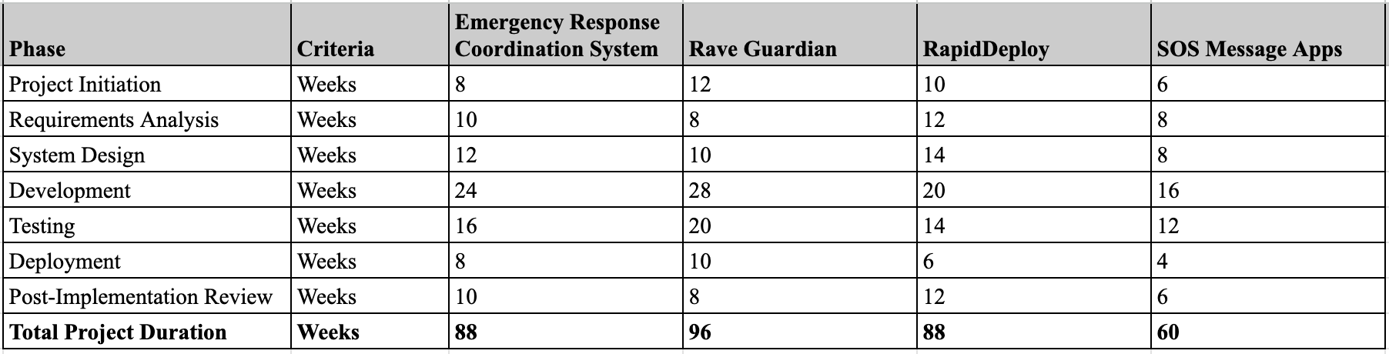

### Technical Resource Management

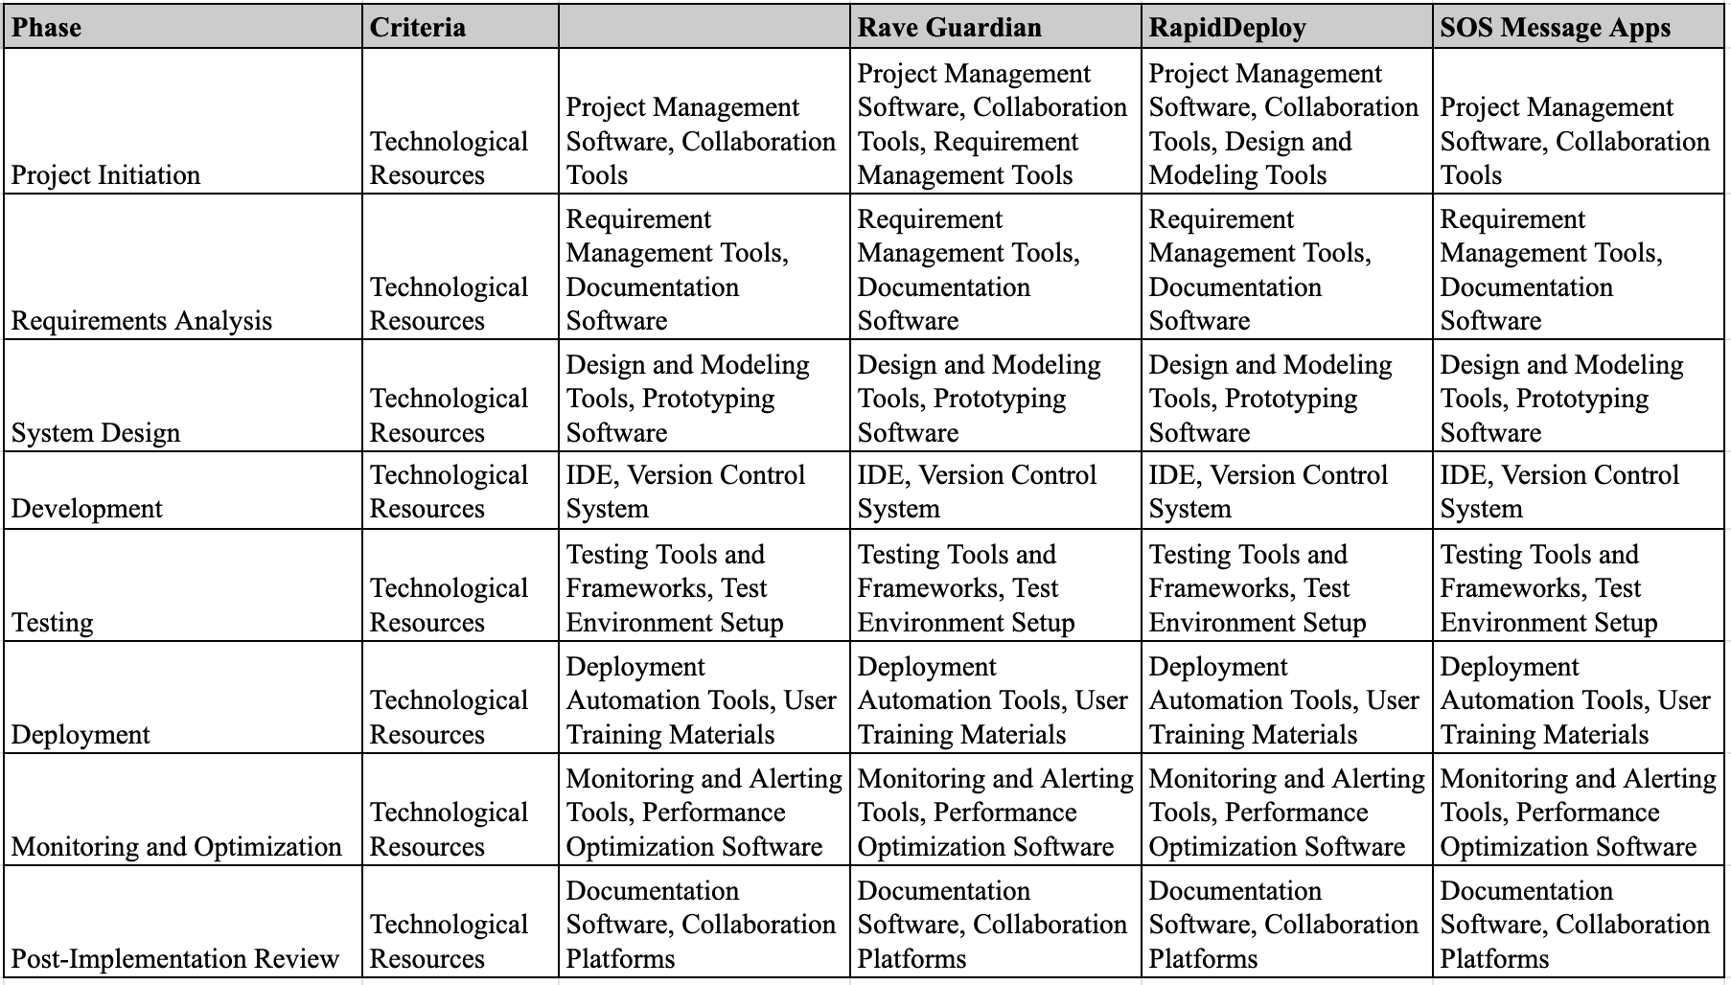

**Conclusion**

The feasibility study demonstrates that ERCS is technically achievable, operationally beneficial, and economically viable. The technical architecture supports scalability and security, while operational adjustments enhance efficiency and adoption. Financially, the project’s ROI and long-term cost savings justify the initial investment, making ERCS a viable and valuable solution for improving emergency response coordination.